# Fluid Mechanics

1. What is a Fluid?

A fluid is a substance that deforms continuously under the application of a shear (tangential) stress no matter how small the shear stress may be

1. Differential vs Integral approach

Differential – taking a differential element to solve the question  
Integral – Control volume approach – through a finite volume (Bernoulli’s equation)

1. Lagrangian vs Eulerian approaches

Lagrangian – Looking and analyzing individual particles in a flow field  
Eulerian – Focus on specific locations in the flow field as a function of time

1. Steady flow and Uniform flow

Steady – Properties at a given point don’t change with time – No temporal acceleration  
Uniform – Properties do not change with position – No spatial acceleration

1. Timelines, Path lines, Streamlines and Streak lines

If a number of adjacent fluid particles in a flow field are marked at a given instant, they form a line in the fluid at that instant; this line is called a **timeline**.  
A **path line** is the path or trajectory traced out by a moving fluid particle. (Usually a single particle or a contaminant)  
**Streamlines** are lines drawn in the flow field so that at a given instant they are tangent to the direction of flow at every point in the flow field. Since the streamlines arc tangent to the velocity vector at every point in the flow field, there can be no flow across a streamline.  
After a short period of time we would have a number of identifiable fluid particles in the flow, all of which had, at some time, passed through one fixed location in space. The line joining these fluid particles is defined as a **streak line**.  
*Thus in a steady flow, path lines, streak lines, and streamlines are identical lines in the flow field.*

1. Shear stress, what is denoted by tau(xy)

*For a fluid, shear stresses arise due to viscous flow.* We have used a double subscript notation to label the stresses. The first subscript (in this case, x) indicates the plane on which the stress acts (in this case, a surface perpendicular to the x axis). The second subscript indicates the direction in which the stress acts.

1. Give some examples of surface forces and body forces.

Surface forces (pressure, friction) are generated by contact with other particles or a solid surface; and body forces (such as gravity and electromagnetic) that are experienced throughout the particle.

1. Is Buoyancy a body force or drag force?
2. What is deformation rate or shear rate?

d(alpha)/dt = d(u)/dy for small angles

**Shear rate** is the **rate** of change of velocity at which one layer of fluid passes over an adjacent layer.

1. Different kinds of fluids. What is Newtonian and non-Newtonian fluid?

Fluids in which shear stress is directly proportional to rate of deformation are Newtonian fluids. Follow Newton’s law of viscosity (valid only for laminar flow) -   
𝛕 = µ (µ - Viscosity, – Kinematic Viscosity)  
The term non-Newtonian is used to classify all fluids in which shear stress is not directly proportional to shear rate.

𝛕 = µ *n* is called the flow behavior index and the coefficient, *k*, the consistency index

1. What are shear thinning, shear thickening fluids and Bingham plastics?

Fluids in which the apparent viscosity decreases with increasing deformation rate (**n < 1**) are called **pseudoplastic (or shear thinning) fluids.** Examples include polymer solutions, colloidal suspensions, and paper pulp in water. If the apparent viscosity increases with increasing deformation rate (**n > 1**) the fluid is termed **dilatant (or shear thickening).** Suspensions of starch and of sand are examples of dilatant fluids. Bingham plastic is a "fluid" that behaves as a solid until a minimum yield stress.

1. In capillary water rises and mercury sinks, why?

Water - glass has low surface tension (N/m) as compared to mercury - glass. Capillary rise – Upward force – Surface tension, downward force – gravity.

1. Significance of Reynold’s number

We can estimate whether viscous forces, as opposed to pressure forces, are negligible by simply computing the Reynolds number. If the Reynolds number is "large," viscous effects will be negligible.

1. Laminar and Turbulent flows – Define.

A laminar flow is one in which the fluid particles move in smooth layers, or laminas; a turbulent flow is one in which the fluid particles rapidly mix as they move along due to random three-dimensional velocity fluctuations. For internal flows, it is generally laminar if R <= 2300 and turbulent for larger values.

1. What is cavitation?

Cavitation occurs when vapor pockets form in a liquid flow because of local reductions in pressure.

1. What is Bernoulli's equation and what are its assumptions?

This equation is subject to the restrictions:

I. Steady flow. 2. No friction (inviscid flow). 3. Flow along a streamline. 4. Incompressible flow.

1. What is the continuity equation? How is it derived?

The Continuity eq is derived from the conservation of mass in a differential fluid element

1. What is the stream function? How to calculate Flow rate from stream function?

Stream function allows us to mathematically represent two entities - the velocity components u (x, y, t) and v (x, y, t) of a two-dimensional incompressible flow-using a single function (x, y, t)

Q =

1. What is a substantial derivative? Derive it.

Refer to pages 199 & 200 of Fox & McDonald.

Substantial derivative (meaning that the time rate of change is reported as one moves with the "substance").

1. Is Acceleration in steady state zero?

In steady state, the temporal acceleration is zero. But, a fluid particle may undergo a convective acceleration due to its motion, even in a steady velocity field.

1. How to write the equation of a streamline?

At each point the streamlines are tangent to the instantaneous velocity vectors.

1. Write Navier-Stokes equation. What are its assumptions and utility?

Derivation – Page 212 to 215 – Fox & McDonald

Derived from Force balance on a differential fluid element   
Total force (surface forces + body forces) = (dm).(Dv/Dt)

1. Explain the significance of terms in Navier stokes?

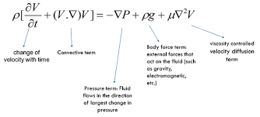

1. What is Euler's Equation?

Navier Stokes’ equation in frictionless flow (inviscid flow) reduces to Euler’s equation.

1. What are the modifications needed in Bernoulli’s equation for bends and viscous flows?
2. Explain the pressure drop term in Bernoulli equation.

Pressure p in Bernoulli equation is for Static pressure.

1. What is a pitot tube? How does it work? Where can you take the free stream pressure for a pitot tube? What is Static pressure, dynamic pressure, and stagnation pressure?

The pitot tube is a differential pressure measuring device. A pitot tube is inserted in an air flow (at STP) to measure the flow speed. The tube is inserted so that it points upstream into the flow and the pressure sensed by the tube is the **stagnation pressure**. The **static pressure** is measured at the same location in the flow, using a wall pressure tap. So, the manometer now reads the d**ynamic pressure** = V2/2 (Dynamic pressure = Stagnation pressure – static pressure) – Refer to page 241 of Fox and McDonald.

The **stagnation** or **total** pressure is the pressure measured at the point where the fluid comes to rest. It is the highest pressure found anywhere in the flow field, and it occurs at the stagnation point. It is the sum of the **static pressure**, and the **dynamic pressure** measured far upstream. It is called the dynamic pressure because it arises from the motion of the fluid.

1. What is an Orifice meter? Explain its working.

Orifice meter is a restriction flow meter (the orifice plate is a thin plate that may be clamped between pipe flanges). The primary disadvantages of the orifice are its limited capacity and the high permanent head loss caused by the uncontrolled expansion downstream from the metering element. Since the location of the pressure taps influences the empirically determined flow coefficient, one must select handbook values of C (discharge coefficient) or K (C*velocity to approach factor = flow coefficient) consistent with the location of pressure taps.

1. What is a Venturi meter? Draw its pressure profile along the length.

The conical diffuser section downstream from the throat gives excellent pressure recovery; therefore, overall head loss is low. Venturi meters are also self-cleaning because of their smooth internal contours.

1. What is Rotameter? How does it work? Is it a variable area or a variable pressure instrument?

Variable area instrument (Pg 372). The disadvantage of restriction flow meters (except the LFE) is that the measured output (6.p) is not linear with the flow rate Q. In operation, the ball or float is carried upward in the tapered clear tube by the flowing fluid until the drag force and float weight are in equilibrium.

1. In which are the losses more, orifice meter or venturi meter?

1. What is a vena contracta?

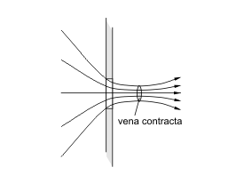**Vena contracta** is the point in a fluid stream where the diameter of the stream is the least, and fluid velocity is at its maximum, such as in the case of a stream issuing out of a [nozzle](https://en.wikipedia.org/wiki/Nozzle) ([orifice](https://en.wiktionary.org/wiki/orifice)).

The maximum contraction takes place at a section slightly downstream of the orifice, where the jet is more-or-less horizontal. The reason for this phenomenon is that fluid streamlines cannot abruptly change direction.

1. Draw the schematic of a float.

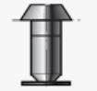

1. What is a fluidized bed?

The term packed bed refers to a condition for which the position of the particles is fixed. In contrast, a fluidized bed is one for which the particles are in motion due to advection with the fluid.

The Reynolds number ReD = VD/is defined in terms of the sphere diameter and the upstream velocity V that would exist in the empty channel without the packing. The quantity is the porosity, or void fraction, of the bed (volume of void space per unit volume of bed)

1. What is terminal velocity?

Terminal velocity is the maximum velocity attainable by an object as it falls through a fluid. It occurs when the sum of the drag force and the buoyancy is equal to the downward force of gravity acting on the object.

1. Which pump is used for slurry transport? Why?

Centrifugal pump, positive displacement can be used for slurry transport. *

1. What is Poiseuille’s equation?
2. What is Darcy’s Law?

**Darcy's law** is an equation that describes the flow of a [fluid](https://en.wikipedia.org/wiki/Fluid) through a [porous](https://en.wikipedia.org/wiki/Porous) medium.

*v0*is the superficial velocity, which is defined as the volume rate of flow through a unit cross-sectional area of the solid plus fluid, averaged over a small region of space. K is the permeability of the medium (function of porosity, shape and size of packing material).

1. What is couette flow? What if the lower surface is moving and the upper surface remains static?

**Couette flow** is the **flow** of a viscous fluid in the space between two surfaces, one of which is moving tangentially relative to the other.

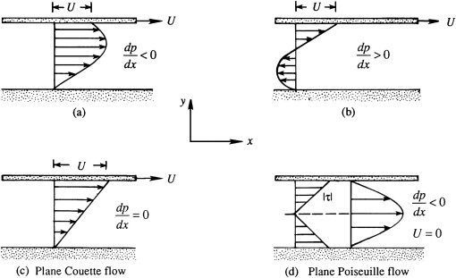

1. What is the working Principle of a centrifugal pump?

Theyuse a rotating impeller to increase the pressure of a fluid. The fluid enters the pump impeller along or near to the rotating axis and is accelerated by the impeller, flowing radially outward into a diffuser or volute chamber (casing), from where it exits into the downstream piping system.

1. Draw the characteristic curve of the centrifugal pump and find pressure drop if head and flow are given.
2. What is NPSH, and how is it related to vapor pressure?

NPSH stands for net positive suction head

1. What is Stokes’ Law?

The force of viscosity on a small sphere moving through a viscous fluid is given by –

where, Fd is the frictional force acting on the interface between fluid and the particle

Assumptions –

Laminar flow, Spherical particles, Homogeneous (uniform in composition) material, Smooth surfaces, Particles do not interfere with each other.

# Thermodynamics

1. What is Carnot Cycle? Draw it.
2. What are isothermal and adiabatic processes?

Isothermal – Constant temperature

Adiabatic – No heat transfer b/w system and surroundings – Q = 0

1. Among those two, which process has more work done?
2. In a process, pressure and temperature change simultaneously, how will you find the entropy?
3. What is the Gibbs Duhem equation?
4. What is departure function?
5. How will you find fugacity coefficient?
6. Explain the 1st, 2nd and 3rd law of thermodynamics.

The **First Law of Thermodynamics** (Conservation) states that energy is always conserved, it cannot be created or destroyed.  
The **Second law of thermodynamics** states that the total [entropy](https://en.wikipedia.org/wiki/Entropy) of an [isolated system](https://en.wikipedia.org/wiki/Isolated_system) can never decrease over time, and is constant if and only if all processes are reversible. Isolated systems spontaneously evolve towards [thermodynamic equilibrium](https://en.wikipedia.org/wiki/Thermodynamic_equilibrium), the state with maximum entropy.

1. Find work done as the function of mole changes.
2. What is entropy? how to reduce entropy of a system?
3. What is Cp and Cv? What is the relation between them? They are valid for what scenario?
4. What is the Van Der Waals equation? What is the significance of a and b in the equation?
5. What is the zeroth law of thermodynamics?
6. Calculate the entropy of double pipe heat exchanger. Will it increase or decrease?
7. What is the expression of entropy? Why 'dQ' not delta Q in expression?
8. Draw an entropy graph for the same heat exchanger.
9. Explain the boiling curve.
10. What is triple point?
11. Write any equation for a non-ideal gas.
12. For reversible Exothermic reaction., if T increases, will equilibrium conversion increase or decrease?
13. State Henry's law.
14. Name few kinds of Equilibrium
15. Write the multicomponent phase equilibrium equations in a non-reacting system?
16. What is Chemical Potential dependent on?
17. What does saying that "The reaction, A+B->C has reached Chemical Equilibrium" signify?

The concentration of reactants and products doesn’t change with time.

1. What is vapor pressure? Relate it to Raoults, Henrys and Dalton's law.

# Heat Transfer and PED 1

1. What is the difference between Conduction and Convection?

We use the term conduction to refer to the heat transfer that will occur **across the medium**. In contrast, the term convection refers to heat transfer that will occur **between a surface and a moving fluid** when they are at different temperatures.

1. What is Fourier’s law?

Fourier’s law is phenomenological; that is, it is developed from observed phenomena rather than being derived from first principles.

or the one-dimensional plane wall shown in Figure 1.3, having a temperature distribution T(x), the rate equation is expressed as shown.

Here, q’’ is the heat flux and k is the thermal conductivity.

1. Write Fourier’s law. Now write it in 3D. How many initial and boundary conditions do you require?

3 BCs in three coordinates are needed – First order in x,y,z

1. What is advection? What is the difference between advection and convection?

The total heat transfer is due to a superposition of energy transport by the random motion of the molecules and by the bulk motion of the fluid. The term convection is customarily used when referring to this cumulative transport, and the term advection refers to transport due to bulk fluid motion.\

1. What are the different modes of heat transfer and their formulas?

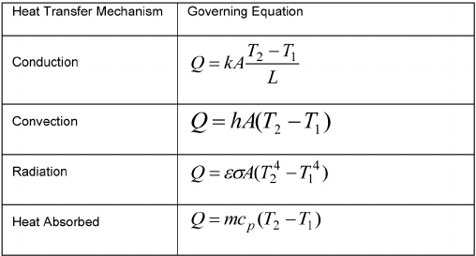

Here, Ɛ is the emissivity. 0 ≤ Ɛ ≤ 1.

The product , commonly termed the ***volumetric heat******capacity***, measures the ability of a material to store thermal energy.

1. What is Stefan Boltzmann Law?

Rate at which energy is released per unit area (W/m2) is termed the **surface emissive power, E**. There is an upper limit to the emissive power, which is prescribed by the Stefan Boltzmann law.   
Total radiant heat power emitted from an ideal surface (blackbody) is proportional to the fourth power of its absolute temperature. ***E* = σ*T*4.** Here, 𝛔 is the Stefan Boltzmann constant. Its value is 5.67 x 108 W/m2K4.

1. What is Newton’s law of cooling?



1. What property of objects affect emission?
2. Derive the heat equation.

In – Out + Gen = Acc on a differential element.

Here, q is the energy generated.

For a 2D system, can be solved using separation of variables or nodal analysis (finite difference eq) which can be solved using Matrix algebra.

1. What are the different types of boundary conditions? Name them.

1. What is the overall heat transfer coefficient? Significance?

With composite systems, it is often convenient to work with an overall heat transfer coefficient U, which is defined by an expression analogous to Newton’s law of cooling. Accordingly,

1. What is contact resistance Rc? How to overcome this?

In composite systems, the temperature drop across the interface between materials may be appreciable. This temperature change is attributed to what is known as the thermal contact resistance, Rt,c.

This can be overcome by using soft metals or thermal greases to fill the gaps between two contact surfaces.

1. What are fins? Name a few of their types.

an extended surface is used specifically to enhance heat transfer between a solid and an adjoining fluid. Such an extended surface is termed a fin.

1. What is fin effectiveness?

It is defined as the ratio of the fin heat transfer rate to the heat transfer rate that would exist without the fin.

1. What is the steady state temperature profile in a rectangular slab if the fluid on one side is held at Tb1 and the fluid on the other side is held at Tb2 for small Biot number and for large biot number?

Biot number provides a measure of the temperature drop in the solid relative to the temperature difference between the solid’s surface and the fluid. If Bi << 1, the resistance to conduction within the solid is much less than the resistance to convection across the fluid boundary layer. Hence, the assumption of a uniform temperature distribution (lumped capacitance method) within the solid is reasonable if the Biot number is small. For large Biot numbers, the temperature difference across the solid is much larger than the temperature difference between the solid and liquid.

1. What is Fourier number?

Where, α = k/, Lc = V/As

It is a dimensionless time, which, with the Biot number, characterizes transient conduction problems. **Fourier number** is a measure of heat conducted through a body relative to heat stored. Thus, a large value of the **Fourier number** indicates faster propagation of heat through a body.

1. What is the difference between Nusselt no. and Biot no.?

Biot number provides a measure of the temperature drop in the solid relative to the temperature difference between the solid’s surface and the fluid. It is the ratio of Conductive resistance by convective resistance. Bi = hL/k.

Nusselt Number is the dimensionless temperature gradient at the surface, and it provides a measure of the convection heat transfer occurring at the surface. Nu = hL/kf

K in Biot’s number is that of the solid medium. Kf in Nusselt number is that of the fluid medium.

1. What differentiates an explicit, finite-difference solution to a transient conduction problem from an implicit solution?

**Explicit** solution is forward difference approximation-based solution. Temps known at a previous time are used to find new temps. To ensure stability, the prescribed value of must be maintained below a certain limit, which depends on and other parameters of the system. This dependence is termed a stability criterion. The criterion is determined by requiring that the coefficient associated with the node of interest at the previous time is greater than or equal to zero.

**Implicit** solution is a backward difference approximation-based solution. New temps of the node are dependent on new temps of adjoining nodes. Implicit method stays stable for all space and time intervals.

1. Write down Dittus Boelter equation and explain all the terms in it.

For fully developed (hydrodynamically and thermally) turbulent flow in a smooth circular tube, the local Nusselt number may be obtained from the Dittus Boelter equation as –

1. What is the Sieder Tate equation?

The Dittus Boelter equations may be used for small to moderate temperature differences, Ts - Tm, with all properties evaluated at Tm. For flows characterized by large property variations, the following equation, due to Sieder and Tate, is recommended, where all properties except s are evaluated at Tm.

1. Is k scalar, vector, or tensor?

If substance is ideal and homogeneous, then scalar.  
Stress is a tensor. For stress, we keep track of a magnitude, direction and which plane the component acts on.

If it is a heterogeneous solid, then k would be a tensor as it depends on the magnitude, direction and the plane.

1. What are the different types/configurations of heat exchangers?

**Double-pipe heat exchanger, Shell and tube heat exchanger, compact heat exchangers** (these devices have dense arrays of finned tubes or plates and are typically used when at least one of the fluids is a gas, and is hence characterized by a small convection coefficient)

1. What are baffles? What are its functions? What are the advantages and disadvantages of baffles?

Baffles are flow-obstructing vanes or panels. Baffles are usually installed to **increase the convection coefficient** of the **shell-side fluid** by inducing turbulence and a crossflow velocity component relative to the tubes. In addition, the baffles physically support the tubes, reducing flow-induced tube vibration.

1. What is overall heat transfer coefficient in heat exchangers? How many resistances are included to calculate 'U'?

This coefficient is defined in terms of the total thermal resistance to heat transfer between two fluids. The coefficient is determined by accounting for conduction and convection resistances between fluids separated by walls. Three resistances are included in ideal case – Convective heat transfer at the two wall boundaries and the conductive resistance for the wall itself. The subsequent deposition of a film or scale on the surface can greatly increase the resistance to heat transfer between the fluids. This effect can be treated by introducing an additional thermal resistance in Equation, termed the ***fouling factor***, Rf. Its value depends on the operating temperature, fluid velocity, and length of service of the heat exchanger.

due to any fins that might be present on the walls of the exchanger. It is given by -

where, f is the efficiency of a single fin. Af is the fin surface area and A is the total surface area.

1. In a condenser, if the baffles are removed, what changes should be made to maintain the same efficiency?

Add fins

1. How can you improve the efficiency of HE without putting in new baffles?

Fins on the outer surface of the tubes?

1. Draw the diagram of a 1-2 heat exchanger. Explain how it works.

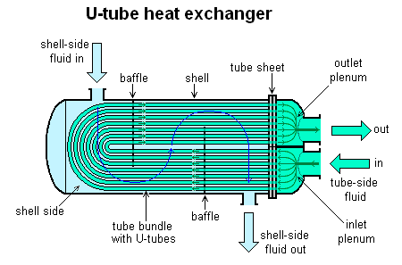

1. How and why to create turbulence in Heat Exchangers?

To increase convective heat transfer coefficient. By adding baffles.

1. What is LMTD? Derive it.

where, 

For co-current heat exchanger, For counter current heat exchanger,

1. What is baffle cut, tie rods, how is leakage in pipes controlled?

A segment, called the **baffle cut**, is cut away to permit the fluid to flow parallel to the tube axis as it flows from one baffle space to another. Segmental cuts with the height of the segment approximately 25 percent of the shell diameter are normally the optimum.

**Tie rods** and spacers are used to hold the tube bundle together and to locate the shell baffles in the correct position. **Tie rods** are circular metal **rods** screwed into the stationary tube-sheet and secured at the farthest baffle by lock nuts.

**Leakages** are controlled by providing scope for expansion – maybe floating head or at the joints of the tubes and tube sheets.

1. What does NTU stand for? Explain the method of calculation using NTU method.

NTU – Net transfer units.

Effectiveness factor Ɛ = q/qmax = f(NTU, Cmin/Cmax) and NTU = UA/Cmin

1. How tubes are fitted inside the shell? How are they attached to the tube sheet?

Primarily, tube-side tube-to-tube-sheet joints need to be strength-welded with light expansion. This is to nullify the possibility of leaking the tube-side fluid through the tube-to-tube-sheet joint.

1. What is Kirchhoff's law for ~~conduction~~ radiation?  
   Total hemispherical emissivity of the surface is equal to its total hemispherical absorptivity if isothermal conditions exist and no net radiation heat transfer occurs at any of the surfaces.
2. Write constitutive equations for any system. How will temperature vary for a bar of metal kept at two different temperatures. Write the PDE for the system and show how temperature varies with time.
3. What Is dirt factor? What is its equation?

Dirt factor or **fouling factor** is represents the theoretical resistance to **heat** flow due to a build-up of a layer of **dirt** or other **fouling** substance on the tube surfaces of the **heat exchanger.** Its value depends on the operating temperature, fluid velocity, and length of service of the heat exchanger.

1. Draw 2-4 pass shell and tube heat exchanger.

2 shell pass, 4 tube pass hear exchanger

1. What is a plate type heat exchanger?

A **plate heat exchanger** is a **type** of **heat exchanger** that uses metal **plates** to transfer **heat** between two fluids. This has a major advantage over a conventional **heat exchanger** in that the fluids are exposed to a much larger surface area because the fluids are spread out over the **plates**.

1. Why don't we have 1,3 Heat Exchangers?

Theoretically possible, very hard to make.

1. What is pool boiling? Draw its related graphs.

Pool of liquid in contact with a superheated solid surface. Bubbles grow and rise.

Read from Incropera (10.3)

1. What is pitch? What are different types of pitch? What are the advantages and disadvantages of both of them?

Tube pitch in heat exchangers is the shortest distance (Tube center to Tube center) between two adjacent tubes in a heat exchanger. There are two types of pitches – Triangular pitch and square pitch. The square pitch is used in situations where the shell-side stream is highly viscous or fouling. The **square pitch enables regular & mechanical scraping/cleaning** of the tube surface. They are also used when operating pressure drop is lower.

**Triangular pitches are more efficient** i.e., accommodate more tubes. Thus, they are the preferred tube arrangement wherever possible. They are used when operating pressure drop is higher.

1. Draw a plot of Utility Cost and Capital Cost vs. (delta T) min.

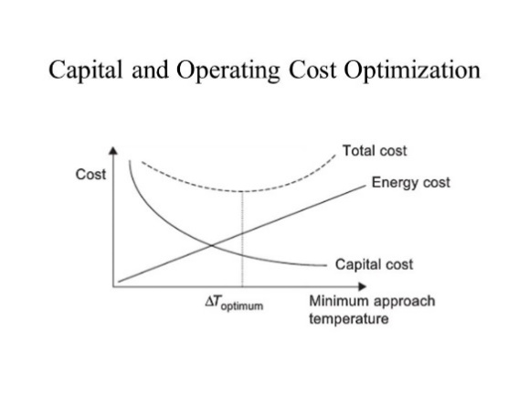

1. What are the Criteria of (CP)hot and (CP)cold above and below Pinch temp.?

# Mechanical Operations

1. Write the equation for filtration?
2. What is the Work Index?
3. What is Bond’s Law, Kicks Law, and Rittinger's law?

Rittinger’s Law : Wreq in crushing is directly proportional to new surface area created.

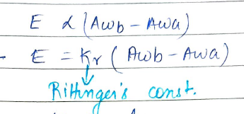

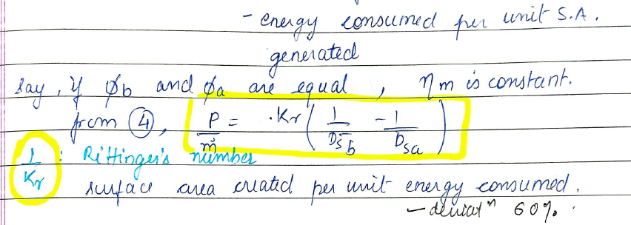

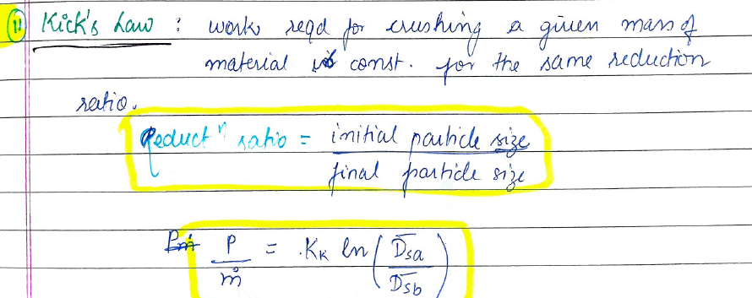

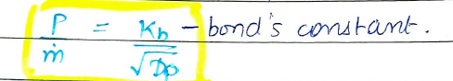

1. How to calculate efficiency?
2. What is trombyl?
3. What is a Weiglow table?
4. What is Blake crusher?
5. What is the Hardgrove crushability index?
6. What is filter aid?
7. What is the angle of nip in roll crusher?
8. Derive critical velocity for a Ball mill.

# Reaction Engineering

1. Draw schematic for the 3 types of reactors.
2. Write mole balance for all 3.
3. What is RTD? What is meant by average residence time?

Residence Time Distribution

1. Are CSTR in series ideal or non-ideal?

1 CSTR is ideal, 2 or more in series CSTR are non ideal.

1. What is u/DL?
2. What is the importance of dispersion number? What is Peclet Number?

Peclet number is a dimensionless number defining the ratio of (Rate of transport by convection )/ (Rate of transport by diffusion or dispersion) = Ul/ Da . Where Da represents Damkohler number, which is a ratio of rate of consumption by reaction to the rate of transport of A by convection

1. How does dispersion number vary when the number of CSTRs in series are increased?

The dispersion number will reduce, as the number of CSTRs in series are increased.

1. Two CSTR of different volumes are connected in series. Find the relation between the initial flow rate and concentration after 2nd reactor, assume first order reaction.
2. What are the disadvantages of using a bigger size catalyst pellet?
3. What are the different types of solid liquid reactors?
4. What are back mix reactors?
5. If rate of reaction is given how will you calculate X if the reaction was given?
6. What is epsilon? Calculate it for a given reaction.
7. What is an auto catalytic reaction? Which reactor should be used?

A+R-->R+R is an auto catalytic reaction. Recycle Reactors are more suitable for such type of reactions.

1. Suppose you have two identical CSTR reactors of volume 2.5 liters each and two PFR of vol 1.5 liters and 1 liter. For any given reaction how will you connect them in series?
2. How pellet size affects mass transfer?
3. Write the Arhenius equation and for two diff Ea, where Ea1>Ea2, Draw the graph of k vs T.
4. For the same volume and flow rate in a CSTR and PFR,which will have a higher conversion?

PFR will have a higher conversion for same volume and flow rate. (For Positive order reactions)

1. What is an elementary reaction?
2. Draw a cylindrical pore and asked to write the constitutive equation for reaction and mass balance.
3. Is recycle reactor Ideal or Non ideal? Why?
4. How can we make ideal CSTR and PFR non ideal?
5. What is the unit of rate constant of n-th order reaction?
6. What is a zeroth order reaction, will it continue forever?

Zeroth order reactions are the reactions whose rate does not depend on the concentration of the reactant.

1. How to decide whether to use cstr or pfr?
2. What is a semi batch reactor?
3. What is micromixing? What is the effect of micromixing on dispersion number?
4. Explain CSTR in series model for non isothermal reactors.

# Mass Transfer 1 and PED 2

1. What is the driving force for Mass Transfer?

Chemical potential (Concentration gradient)

1. What is Fick’s 1st law?

The molar flux of a species relative to an observer moving with molar average velocity is proportional to the concentration gradient of the species.

Remember –

N is molar flux with respect to a stationary observer.

I is the molar flux wrt an observer moving with mass average velocity

J is the molar flux wrt an observer moving with molar average velocity.

*DAB* is a property of the binary mixture known as the binary diffusion coefficient.



 and 



for liquid phase diffusion.

1. What is the basic law of mass transfer? Write its expression.

Fick’s law of diffusion.

1. How will you define molar flux J? How does it vary with different frames of reference?

J is the molar flux of A (Moles per unit area per unit time) with respect to an observer moving with the molar average velocity of the mixture.

1. What is the analogy between heat, mass and momentum? What is the analogous term for diffusivity in heat transfer and momentum transfer?

Fick’s law of diffusion analogous to Fourier’s law of heat conduction in Heat and Newton’s law of viscosity in Momentum.

 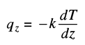 

Conductivity in Heat transfer and viscosity in momentum transfer are analogous to Diffusivity in Mass transfer.

1. What is equimolar counter diffusion?

Situation when the two components of a mixture diffuse at equal rates but in opposite directions.

1. What are the methods used for finding diffusivity, both gas phase and liquid phase?

**Gas phase diffusion coefficient –**

* 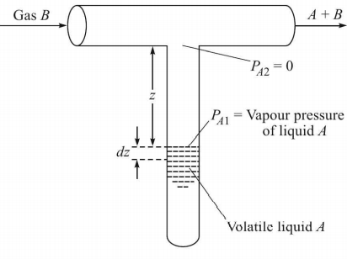Twin bulb method – Equimolar counter diffusion in two bulbs with A and B at same pressure – analysis of their concentrations after a certain time interval
* Stefan tube experiment – Diffusion of A through non-diffusing B. Applicable when A is a volatile liquid and B is insoluble in A. The drop in liquid level of A is noted and analyzed to derive the diffusivity of A in B.
* There are also some predictive equations to find the gas phase diffusivity like that of **Chapman and Enskog**.

**Liquid phase diffusion coefficient –**

* The diaphragm cell – Solutions of A in B are taken at two concentrations in the two sides of a diaphragm in the cell across which diffusion occurs. Based on the area of cross-section of the diaphragm, the porosity and the tortuosity factor (𝛕), the final concentrations of A in both the cells, the diffusivity is determined.
* Predictive equations can also be used such as the Wilke-Chang eq or the Leffler Cullinan eq

1. What are different kinds of diffusion? There is carbon charcoal and air is passed on it, what kind of diffusion is it?

Interphase diffusion, Knudsen diffusion, surface diffusion and self diffusion.

Carbon charcoal – Surface diffusion? (Upon the active sites)

1. What is Knudsen diffusion?

**Knudsen diffusion** is a means of [diffusion](https://en.wikipedia.org/wiki/Diffusion) that occurs when the scale length of a system is comparable to or smaller than the [mean free path](https://en.wikipedia.org/wiki/Mean_free_path) of the particles involved. Here, the collisions with the walls of the pores become more significant than the collisions with other molecules. Hence rate of diffusional transport is now a function of the diameter of the pore, molecular velocity and concentration gradient or partial pressure. Knudsen diffusion becomes important in pore size is less than 50nm.

Knudsen diffusivity,

Where,

rp = radius of passage

vT = RMS velocity

1. What is surface diffusion and self-diffusion?

Surface diffusion is the transfer of adsorbed molecules on a surface in the presence of a concentration gradient. Happens on active sites of a catalyst surface.

Self-diffusion refers to the diffusion of molecules in a pure substance. Rate of transport across any plane over a macroscopic time scale is zero.

1. What are the modes of convective mass transfer?

Natural or free convection and forced convection (Example – sugar cube at the bottom of a beaker of water (no free convection) vs at the top (free convection))

1. What are the various theories of mass transfer? What were the model parameters in each theory?

* **Film theory** –

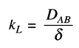

* **The penetration theory –**

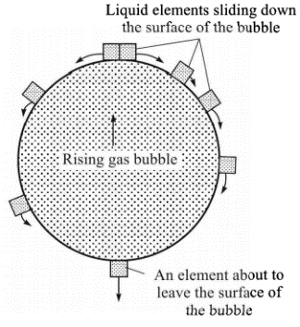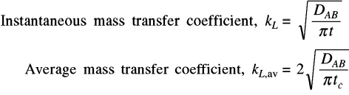

* **The surface renewal theory** –

The penetration theory assumes that the contact time is same for all, which is not true. where, s is the fractional rate of surface renewal

* **The Boundary layer theory** – Using Sherwood number

1. What is ‘Colburn analogy’?

It related the Mass transfer coefficient to the friction factor by introducing the Colburn j-factor.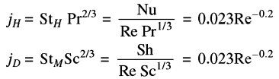

1. What is the function of Reflux Drum?

Reflux drum serves as a distribution point for reflux and distillate. The **purpose of reflux** is to provide down-flowing liquid throughout the rectification section to contact with the up-flowing vapor in order to achieve stage-by-stage equilibrium heat and mass transfer and, hence, purification of the top product.

1. What is the phase rule and degrees of freedom?



The number of variants that have to be specified additionally to define the system completely is the degrees of freedom.

1. Raoult’s law and Henry’s law.

**Raoult’s law**

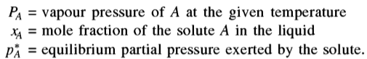

**Henry’s law**

1. What is the difference between dialysis and RO?



[Osmosis](http://socratic.org/biology/movement-in-and-out-of-cells/osmosis) is the [diffusion](http://socratic.org/biology/movement-in-and-out-of-cells/diffusion) (i.e. movement) of a solvent (e.g. **water**) across a semi-permeable membrane. Dialysis is the separation (i.e. movement) of **molecules** themselves.

Dialysis is the movement of molecules in solute (e.g. glucose) and osmosis is the movement of the solvent (water) itself.

1. Why do we use mole ratios and not mole fractions directly?

To obtain an operating line that is a as straight line.

1. What is a stage? What is stage efficiency?

Any entity in which two immiscible phases are brought into intimate contact is called a stage. An ideal stage has both the phases in equilibrium when they leave the stage. Stage efficiency gives a measure of how close to equilibrium are the two phases when they leave the stage.

1. How is pressure maintained using a reflux drum?
2. How to increase the purity of top product in a distillation column?
3. W = K* Driving force. Is this valid for all mass transfer processes?
4. What is the molar flux formula for multi-component mixture?
5. What is Relation between gas diffusion coefficient, temperature and pressure?
6. What are the conditions which make Dab = Dba relation valid?

For a binary mixture of constant molar density.

1. For a distillation column, design the trays for the column.
2. Write mass, component, and energy balance equations for each tray
3. Write the equations of heat transfer through the distillation column wall and how it will affect the composition and temperature of products.
4. Relative volatility is a function of which parameters? Derive the relation using Dalton and Raoult's Law.

Dalton’s law – Total pressure of a mixture of gases = sum of partial pressures of all the components or constituent gases.

1. Perform Bubble point calculation.
2. What is the significance of Schmidt Number?

Schmidt number gives the relative growth of concentration boundary layer and velocity boundary layer.

1. What is reactive distillation?

# Instrumentation and Process Control

1. What is the 1st order system? Write a transfer function for the 1st order system?
2. What is the reason for offset in P-controller?
3. Plot response of 1st order system for step input change. What is time constant?

# Mass Transfer 2

1. What is osmotic pressure?
2. What is SMP?
3. What is the Vant-hoff equation?
4. What is dialysis? Explain.
5. Explain Liquid Liquid Extraction.
6. What is the difference between leaching and extraction?
7. What is the difference between extraction and distillation?

Distillation separates on the basis of differences in boiling points of the components, while extraction separates on the basis of differences in solubility in the extracting solvent.

# Transport Phenomena

1. What is the boundary layer?

A consequence of the fluid–surface interaction is the development of a region in the fluid through which the velocity varies from zero at the surface to a finite value associated with the flow. This region of the fluid is known as the **hydrodynamic, or velocity, boundary layer**. Moreover, if the surface and flow temperatures differ, there will be a region of the fluid through which the temperature varies from at y = 0 to in the outer flow. This region is called **the thermal boundary layer.**

1. Velocity Boundary layer development on a flat plate

To determine the type of flow, we need the critical Reynold’s number for flow over a flat plate.

1. Draw thermal and momentum boundary layer? Which will be bigger and why?

1. What are Reynolds number, Prandtl number and Schmidt number?

Reynolds number ReL may be interpreted as the ratio of inertia to viscous forces.

Schmidt Number Sc is a measure of the relative effectiveness of momentum and mass transport by diffusion in the velocity and concentration boundary layers.

1. What is the Reynolds analogy?

For a flat plate parallel to the incoming flow, we have dp*/dx* = 0 and there is no variation in the free stream velocity outside the boundary layer. Under such conditions where Pr = Sc = 1 (i.e.; dp*/dx* = 0),

1. What is Peclet Number, Lewis Number?

Pe = Re*Pr, Le = Sc/Pr

1. What is Nusselt Number?

This parameter is equal to the dimensionless temperature gradient at the surface, and it provides a measure of the convection heat transfer occurring at the surface. The Nusselt number is to the thermal boundary layer what the friction coefficient is to the velocity boundary layer.

1. What is Sherwood Number?

Sherwood number is to Concentration boundary layer what Nusselt number is to thermal boundary layer.

1. List the analogous dimensionless numbers in Momentum, heat and Mass transfer.

Re – Pr – Sc

Cf – Nu – Sh

1. What are transport phenomena?

The subject of transport phenomena includes three closely related topics: fluid dynamics, heat transfer, and mass transfer. Fluid dynamics involves the transport of momentum, heat transfer deals with the transport of energy, and mass transfer is concerned with the transport of mass of various chemical species.

1. Write relation between boundary layer thickness and distance travelled for flow, heat and mass?
2. Draw Thermal and Hydrodynamic boundary layers for three cases of Pr.

The thermal diffusivity α has the same dimensions as the kinematic viscosity namely, (length)*/time. When the assumption of constant physical properties is made, the quantities and α occur in similar ways in the equations of change for momentum and energy transport. Their ratio v/a indicates the relative ease of momentum and energy transport in flow systems. This dimensionless ratio called the Prandtl number is given by –

If Pr = 1, velocity and thermal BL will coincide.

If Pr > 1, velocity BL thicker than thermal BL

If Pr < 1, velocity BL thinner than thermal BL

# Chemical Process Technology

1. What are desirable properties of crude?
2. What are crude prices going down?
3. What is the chemical name of bleaching powder?
4. How will you convert toluene to nitrotoluene? What catalyst could be used? How many isomers are possible of nitrotoluene?
5. What is calorific value?
6. What is the composition of LPG?

# Biochemical Engineering

1. Write the formula for Michaelis Menten Kinetics.

E+S --> E+P ::: E+S<--__> ES ES--> E+P

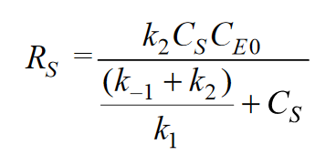 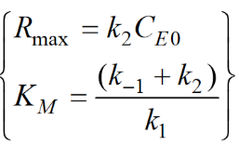

1. Write the formula for the same with Competitive Inhibition?

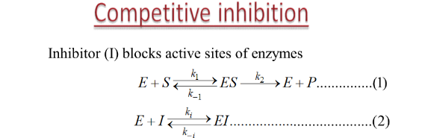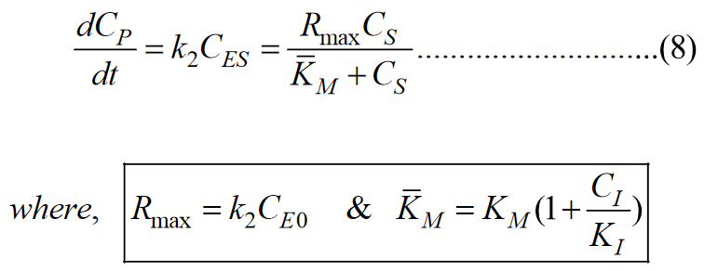

1. Given a CSTR and 2 equations, A + B -> R (K1), R + B ---> S (K2), K1/ K2 ---> infinite, then how can you attain maximum concentration of S? Explain.
2. What is the difference between ideal and non ideal reactors? Give an example for a non ideal reactor.
3. How to find Eigenvalues? What is their significance?

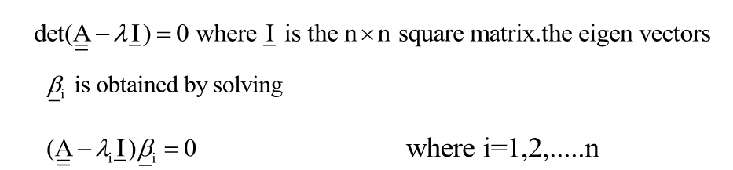

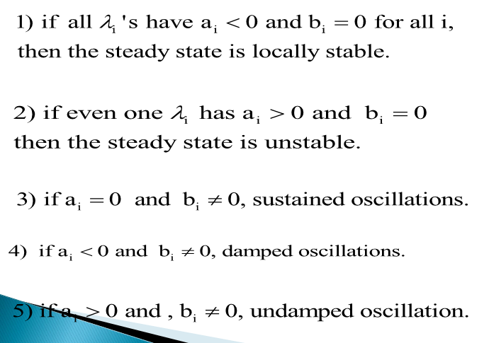

1. Explain neutral stability and its related graphs.

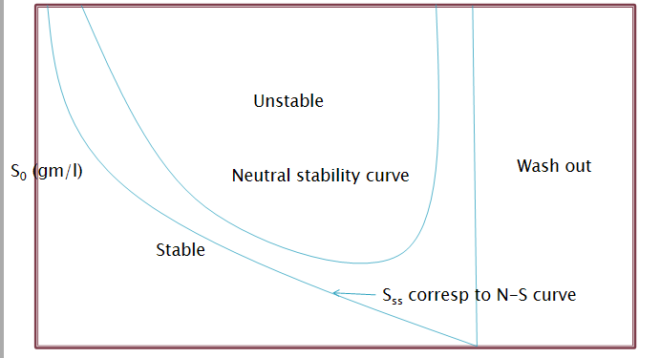

1. What is competitive Inhibition?



1. What is Substrate Inhibition and its rate equation?

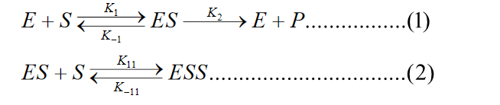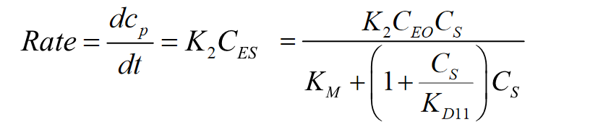

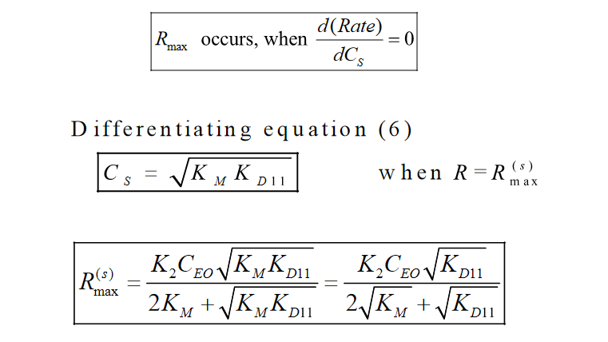

1. Explain the Monod Growth Model.

Unstructured and Non segregation Model.

Assumptions :

1. A single enzyme system with Michaelis Menten Kinetics is responsible for uptake of substrate S, and the amount of that enzyme or its activity is sufficient low to be growth rate limiting.
2. A single chemical species is growth rate limiting while changes in other nutrients have no effect.
3. The relationship of specific growth rate to substrate concentration assumes the form of saturation kinetics
4. Applicable when growth is slow and population density is low.

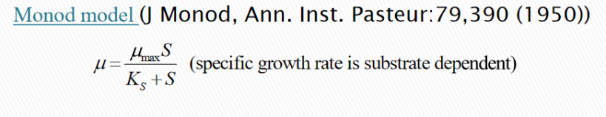

1. What is the significance of process stability and how to judge the stability based on eigenvalues?

# Mathematics

1. What is Newton Raphson method?
2. Are all methods iteration based?
3. Have you heard about Gauss elimination?
4. Can Newton Raphson be used to solve a 10x10 matrix?
5. What is multivariate Newton Raphson?
6. What are the methods to solve ODE and PDE?
7. What is Laplace transformation? Why do we do it ?
8. How do you find Eigenvector?
9. How to solve a series of n linear equations?
10. How do you solve a PDE.Tell the numerical methods which you are familiar with.
11. If I give you about 60 linear equations, how will you solve them?
12. What is Euler's forward method and Euler's Backward Method? Which is good and why? Among the two which is an implicit and which is an explicit method?
13. How to solve odes both numerically and analytically

